**GIT-4**

Implement conflict resolution when multiple users are updating the trunk (or master) in such a way that it results into a conflict with the branch’s modification.

Step1:Verifying the master is clean

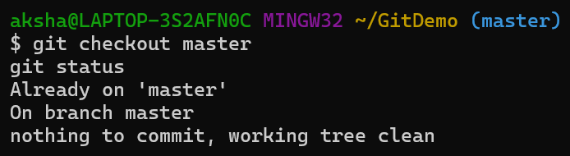

Step2: Creating a New Branch and Add File

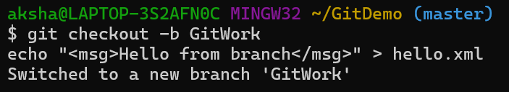

Step3: Staging and Committing the File in GitWork

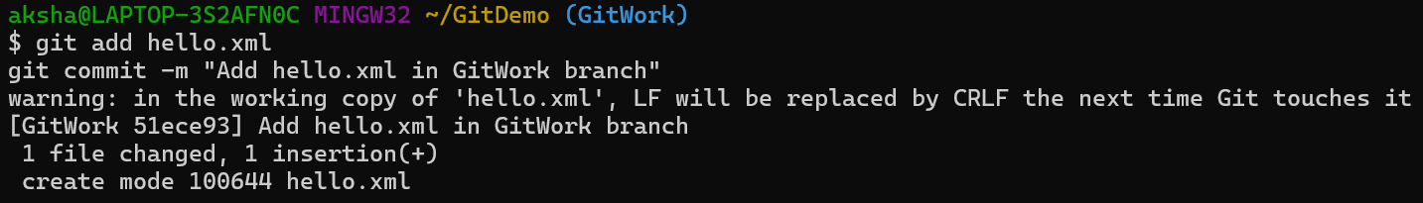

Step4: Switching Back to Master and Modifying Same File

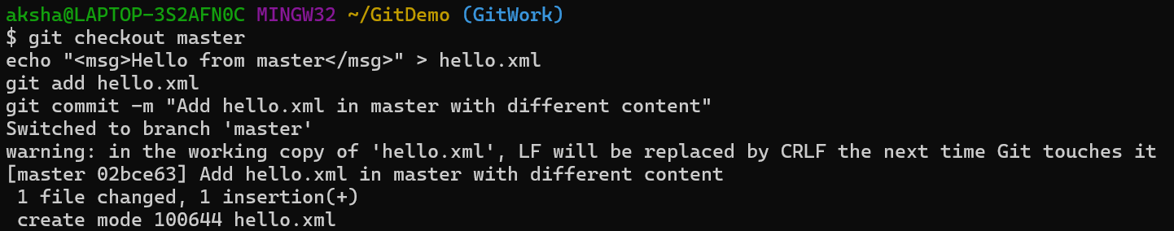

Step5: Observing the Commit Log

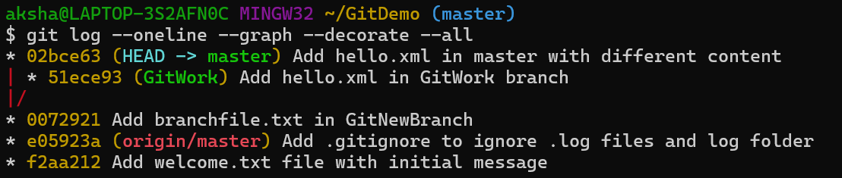

Step6: Configuring and Using Diff Tool

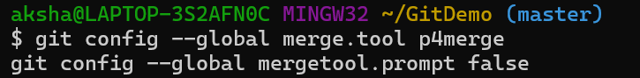

Step7: Merging GitWork into Master

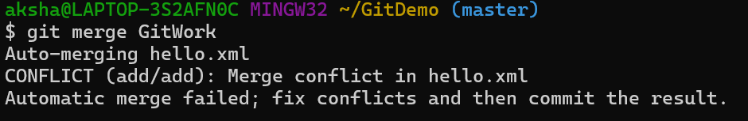

Step8: Observing the Conflict

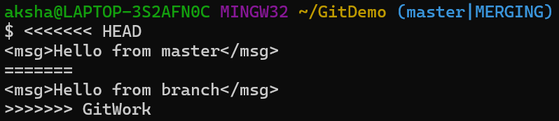

Step9: Resolving Conflict



Step10: Staging and Committing the Resolved File

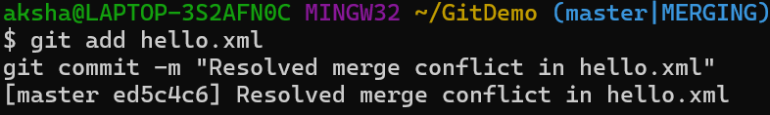

Step11: Adding Backup Files to .gitignore

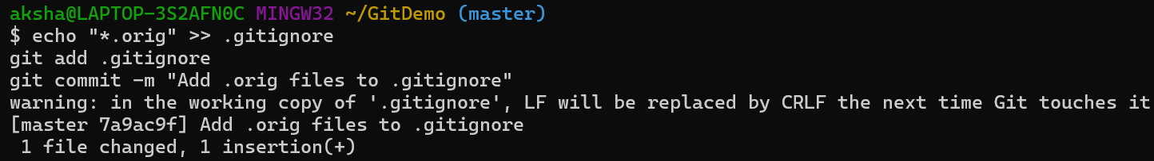

Step12: Listing All Branches

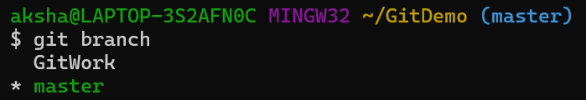

Step13: Deleting the Merged Branch



Step14: Viewing Final Merge History

